Truncated Solid
# Source: AI Source: Provided by: [Data Path: Persons Table -> ID Column: 1, Name_En Column: Motasem Essam] -> From: [ChatGPT] on [7/25/2026]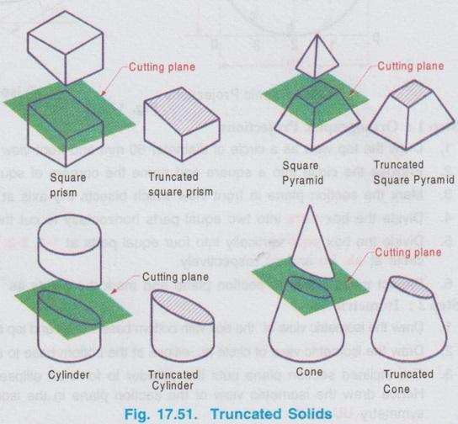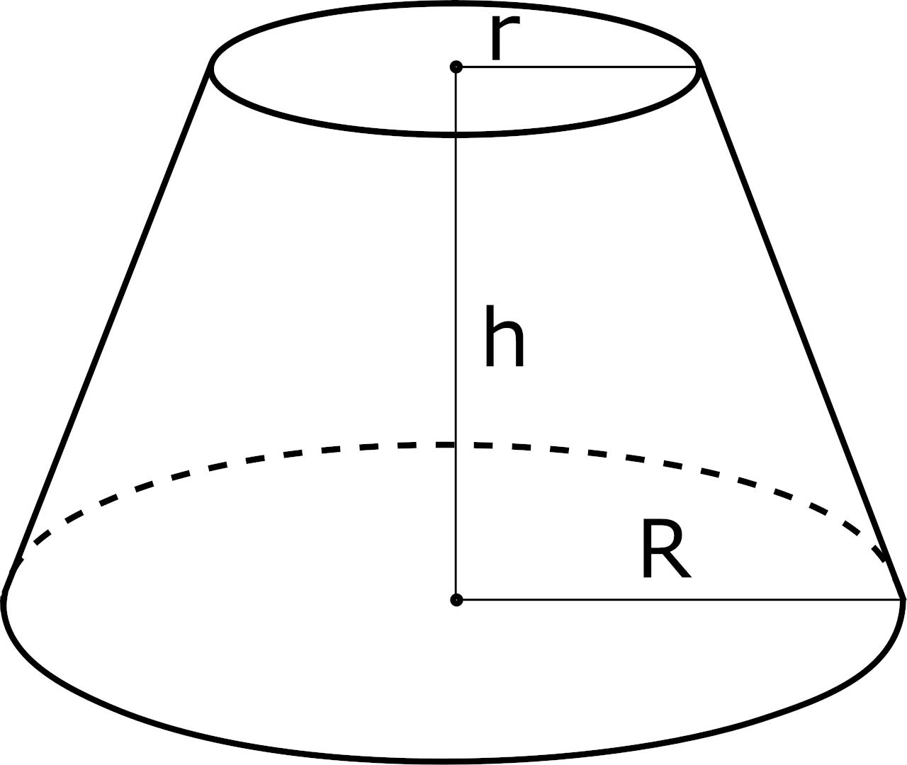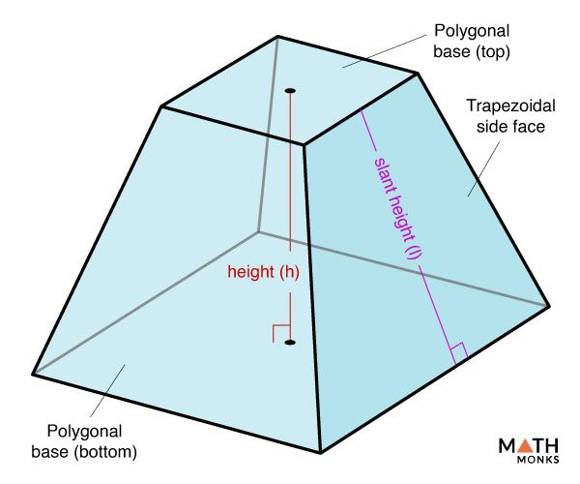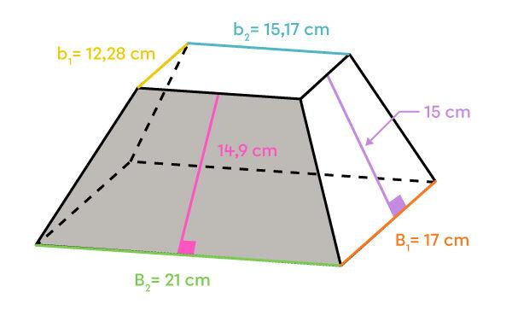

Definition
# Source: AI Source: Provided by: [Data Path: Persons Table -> ID Column: 1, Name_En Column: Motasem Essam] -> From: [ChatGPT] on [7/25/2026]
A Truncated Solid is a three-dimensional geometric solid formed by cutting off a portion of an original solid using a plane or, in more general constructions, one or more cutting surfaces.
The cut creates a new face or surface called a Truncation Face. The resulting solid retains the remaining portion of the original solid, but its shape and geometric properties are changed.
Truncation can be applied to many types of solids, including prisms, pyramids, cones, cylinders, and polyhedra.

Simple Definition
# Source: AI Source: Provided by: [Data Path: Persons Table -> ID Column: 1, Name_En Column: Motasem Essam] -> From: [ChatGPT] on [7/25/2026]
A Truncated Solid is a solid created by removing part of an original three-dimensional shape through a cut.

Geometric Structure
# Source: AI Source: Provided by: [Data Path: Persons Table -> ID Column: 1, Name_En Column: Motasem Essam] -> From: [ChatGPT] on [7/25/2026]
A typical truncated solid consists of the following components:
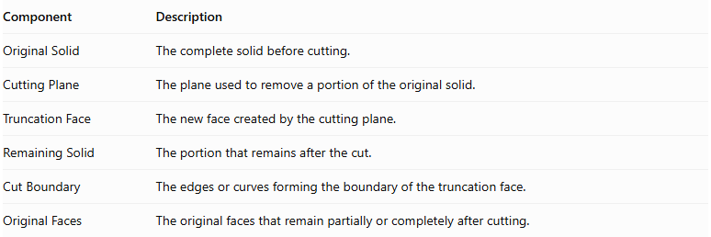
Component | Description
Original Solid | The complete solid before cutting.
Cutting Plane | The plane used to remove a portion of the original solid.
Truncation Face | The new face created by the cutting plane.
Remaining Solid | The portion that remains after the cut.
Cut Boundary | The edges or curves forming the boundary of the truncation face.
Original Faces | The original faces that remain partially or completely after cutting.
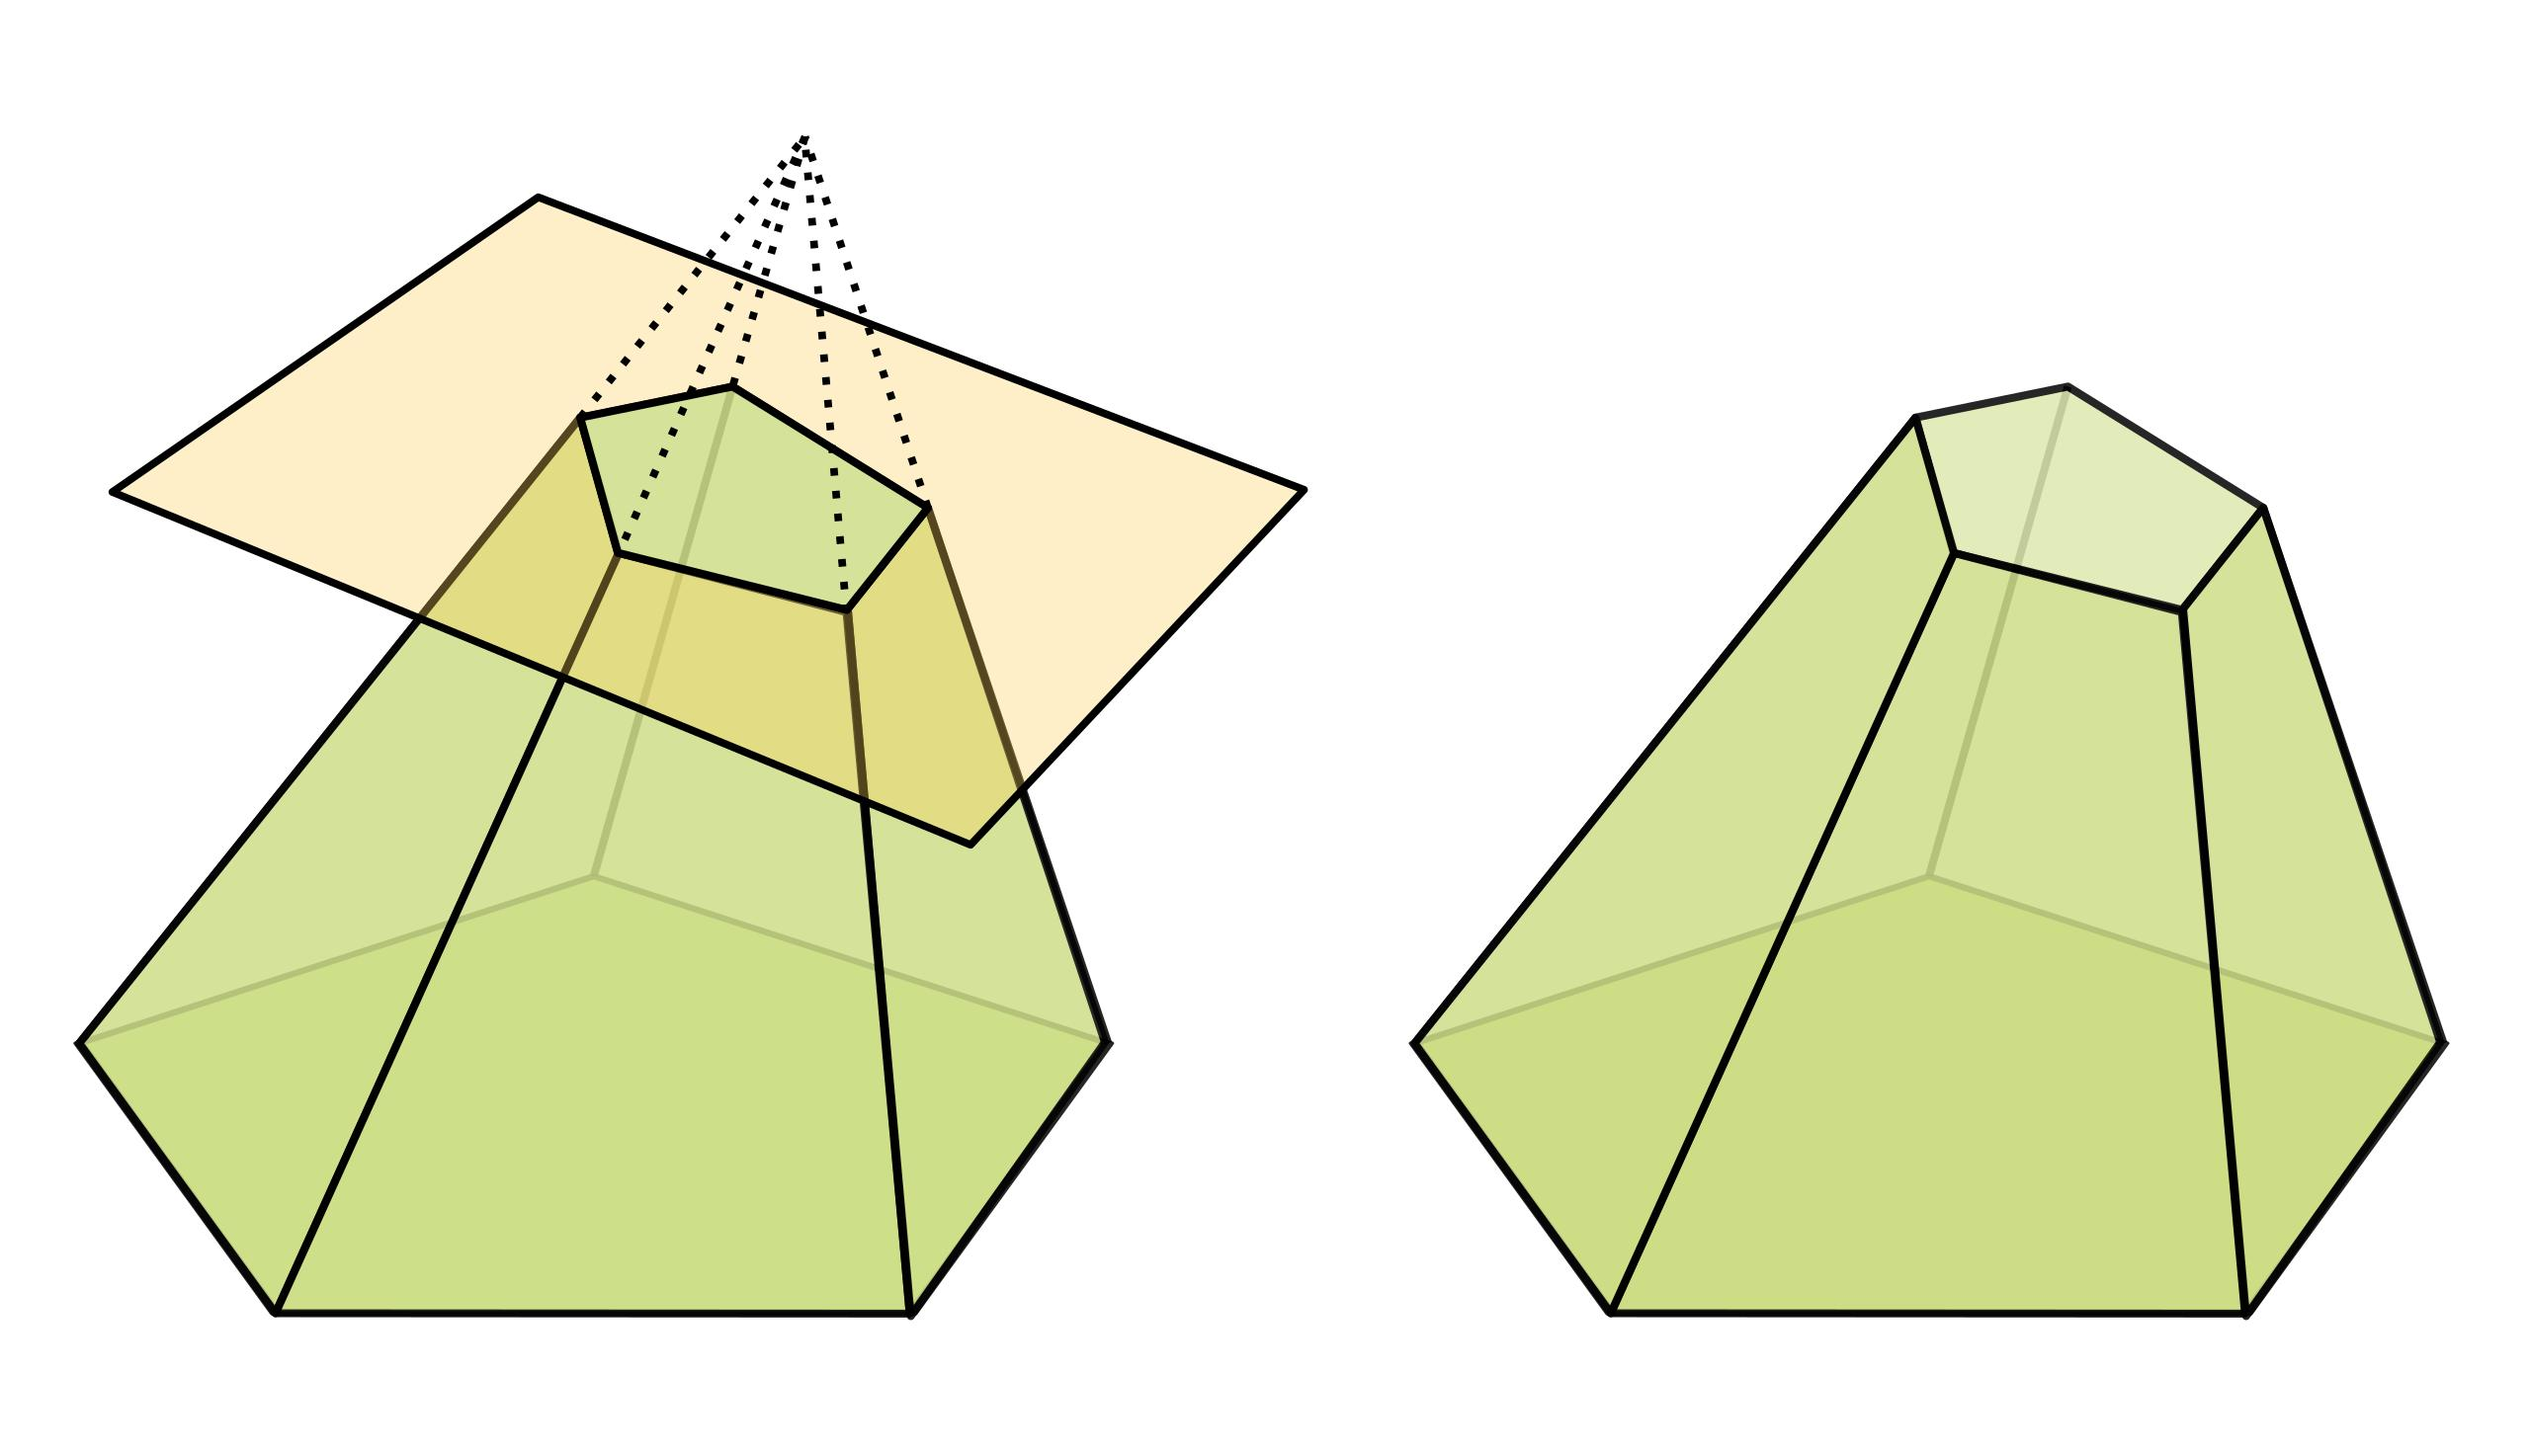

Truncation Process
# Source: AI Source: Provided by: [Data Path: Persons Table -> ID Column: 1, Name_En Column: Motasem Essam] -> From: [ChatGPT] on [7/25/2026]
The formation of a truncated solid generally follows these steps:
- Start with an original three-dimensional solid.
- Define a cutting plane or surface.
- Remove the portion of the solid on one side of the cutting plane.
- Retain the remaining portion.
- Identify the newly created truncation face or surface.
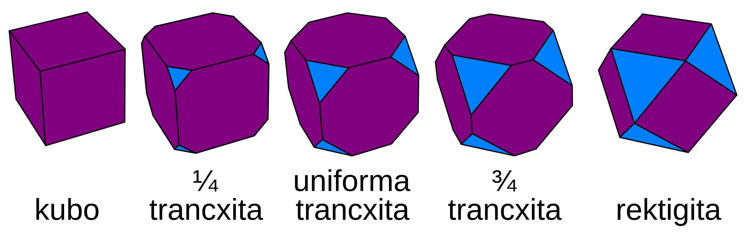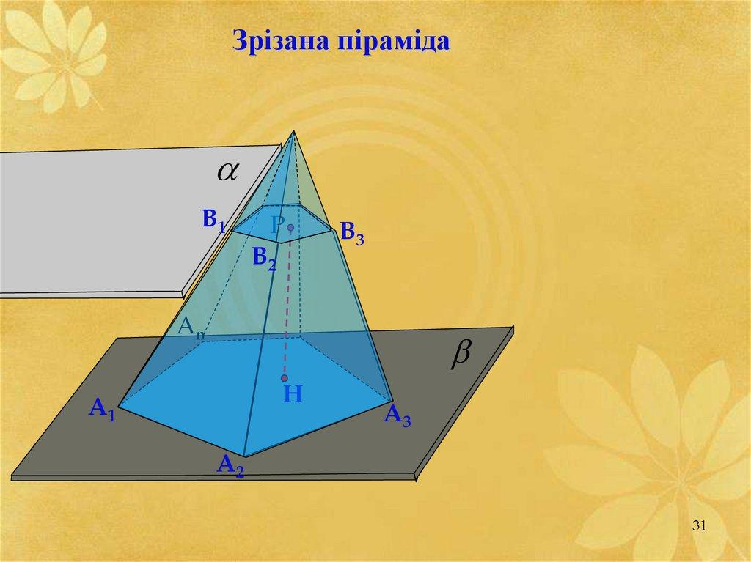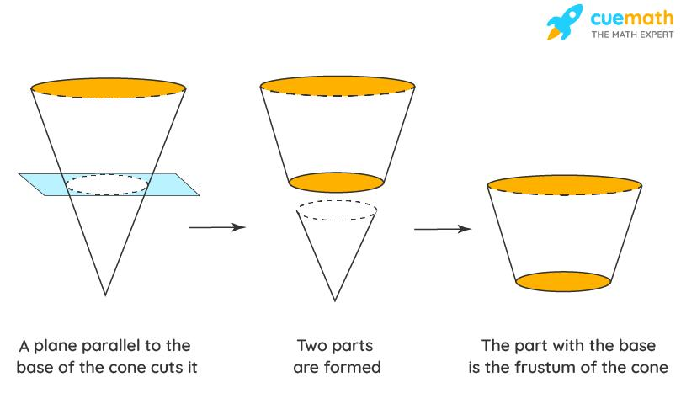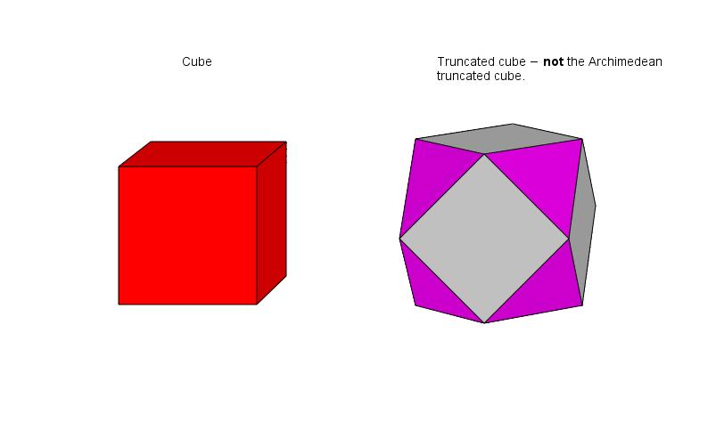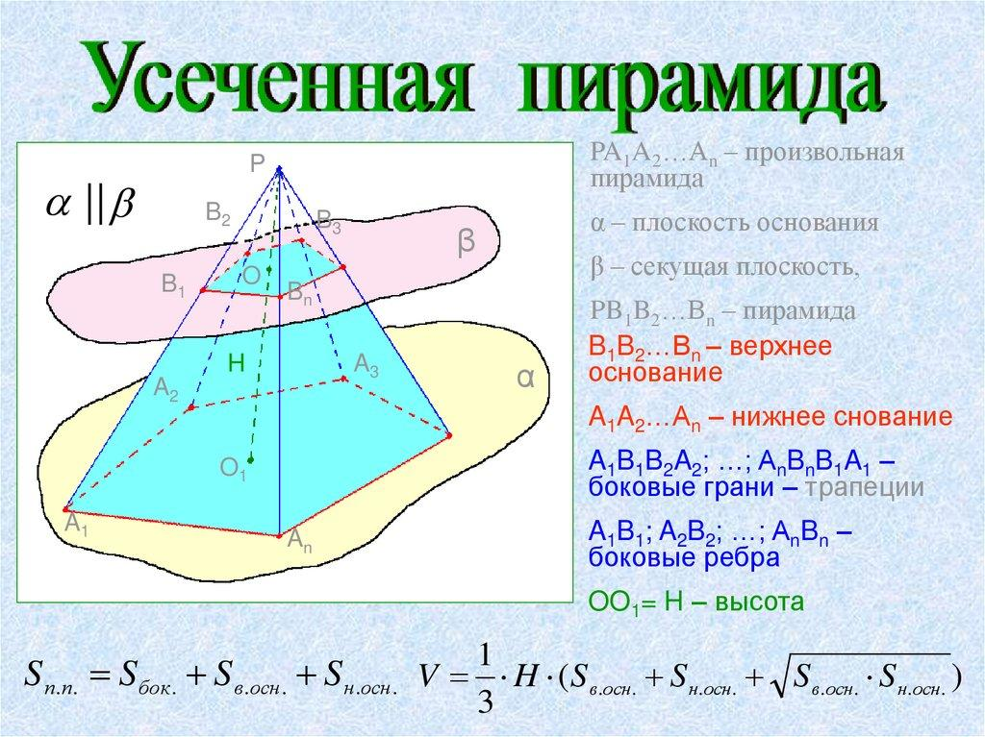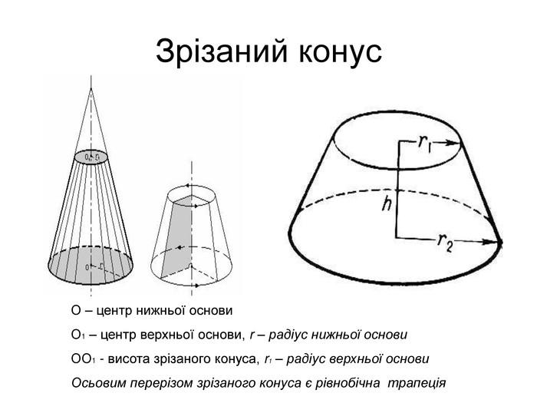

Types of Truncated Solids
# Source: AI Source: Provided by: [Data Path: Persons Table -> ID Column: 1, Name_En Column: Motasem Essam] -> From: [ChatGPT] on [7/25/2026]
Truncated solids can be classified according to the original solid from which they are formed.

Truncated Polyhedra
# Source: AI Source: Provided by: [Data Path: Persons Table -> ID Column: 1, Name_En Column: Motasem Essam] -> From: [ChatGPT] on [7/25/2026]
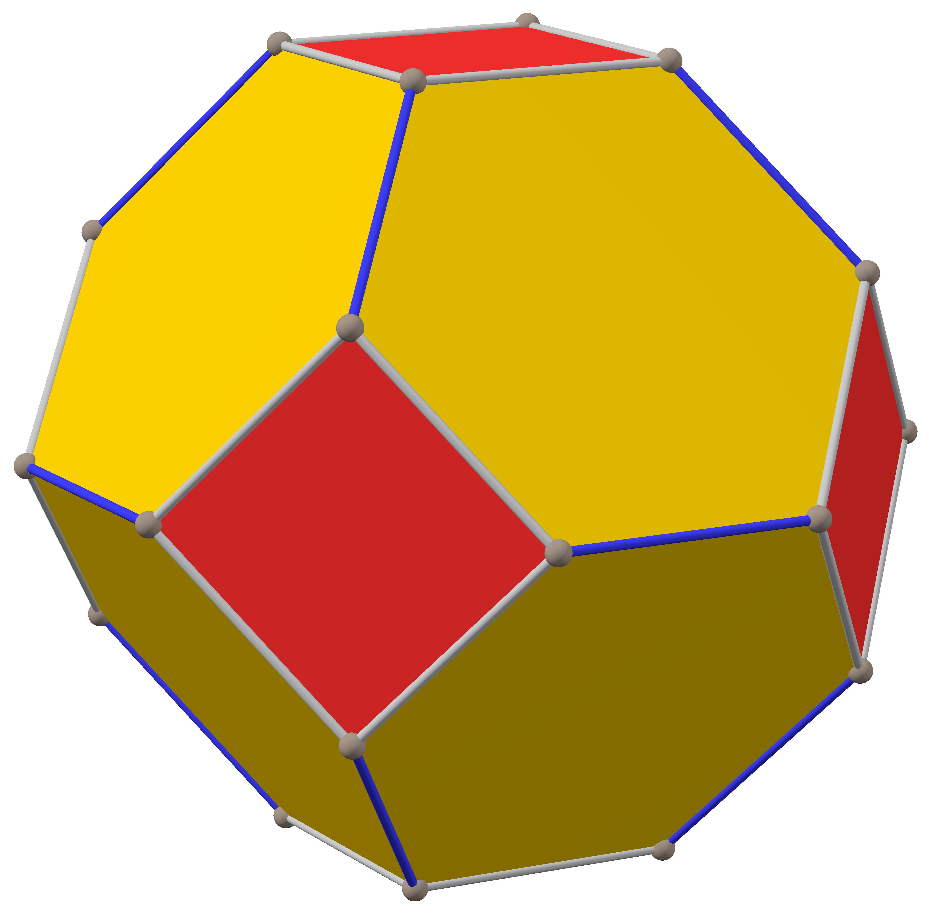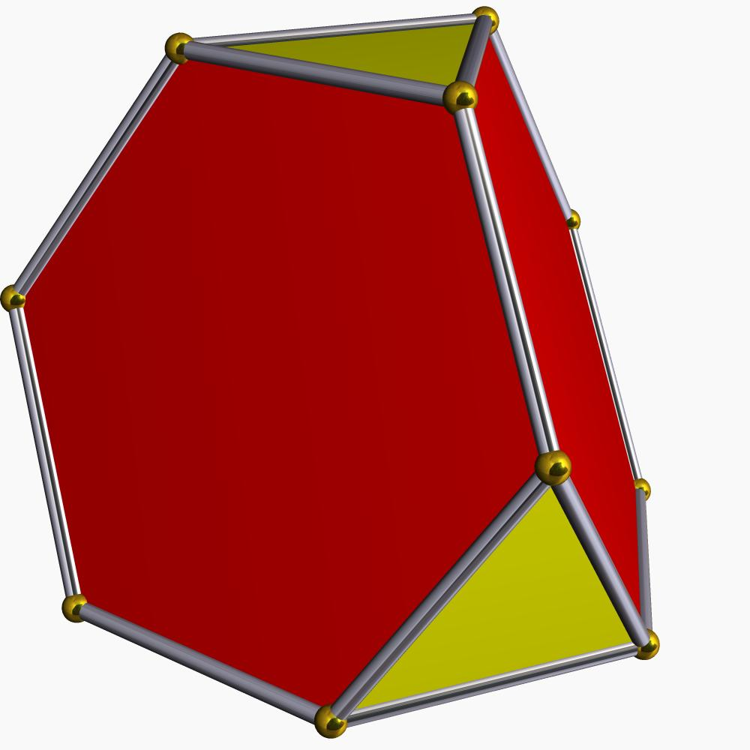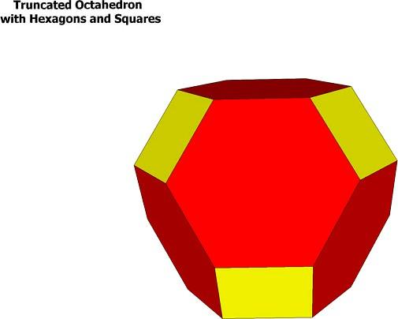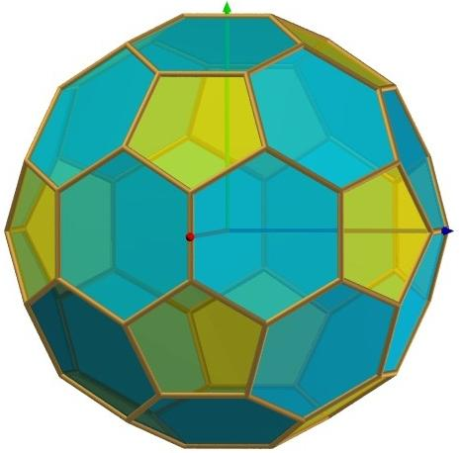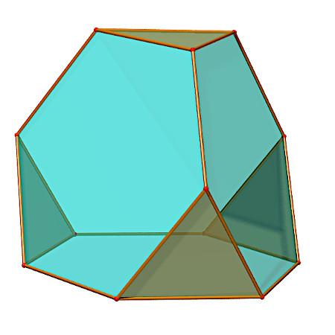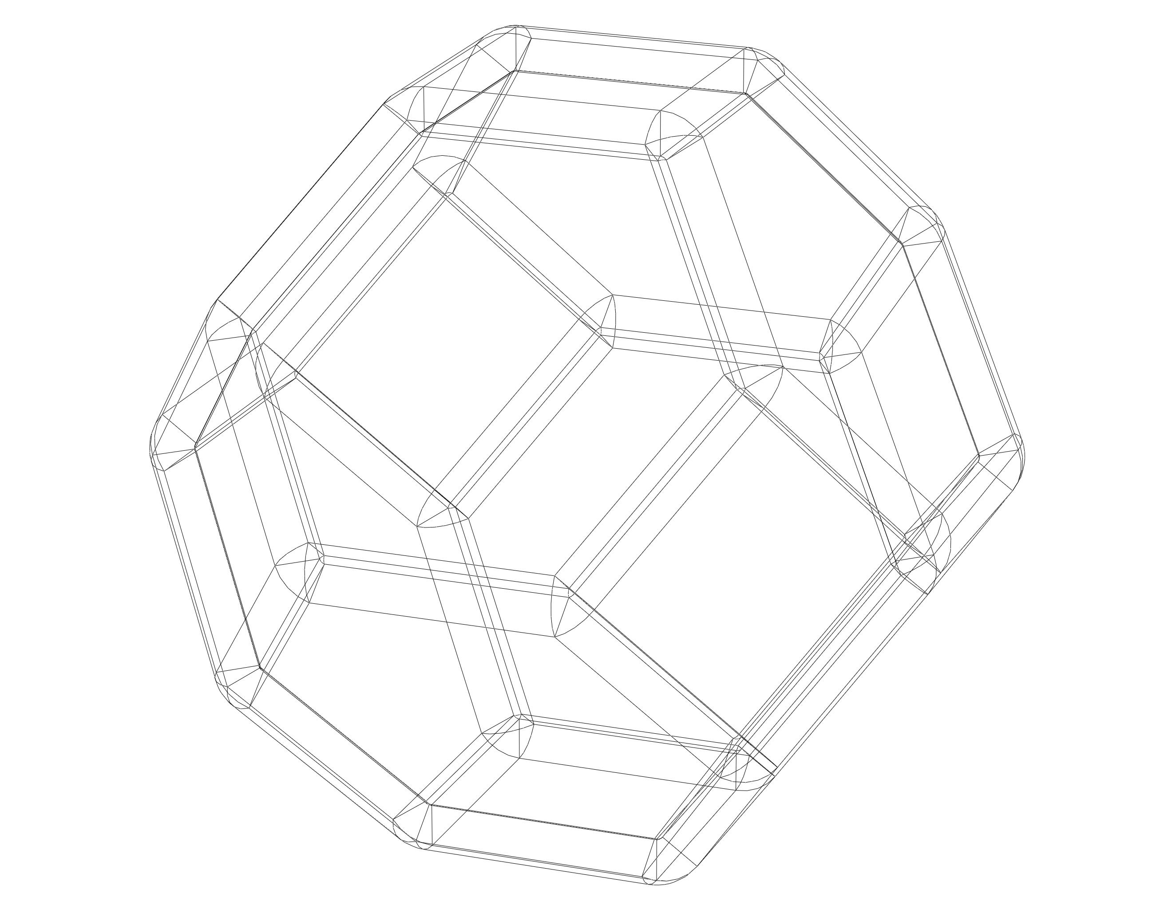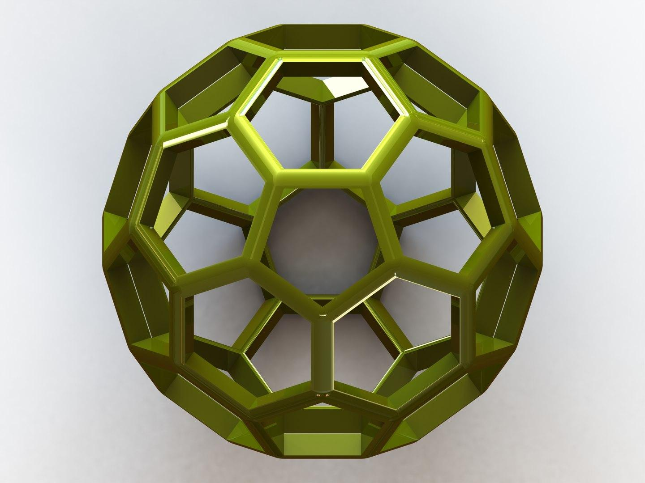
These are formed by cutting off portions of polyhedra, usually at their vertices or along their edges.
Examples:
- Truncated Cube
- Truncated Tetrahedron
- Truncated Octahedron
- Truncated Icosahedron
- Truncated Dodecahedron

Truncated Prisms
# Source: AI Source: Provided by: [Data Path: Persons Table -> ID Column: 1, Name_En Column: Motasem Essam] -> From: [ChatGPT] on [7/25/2026]
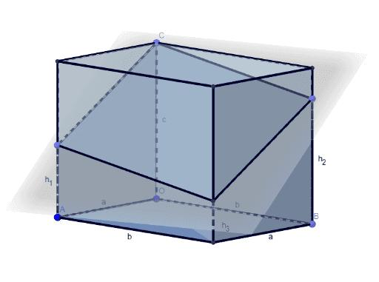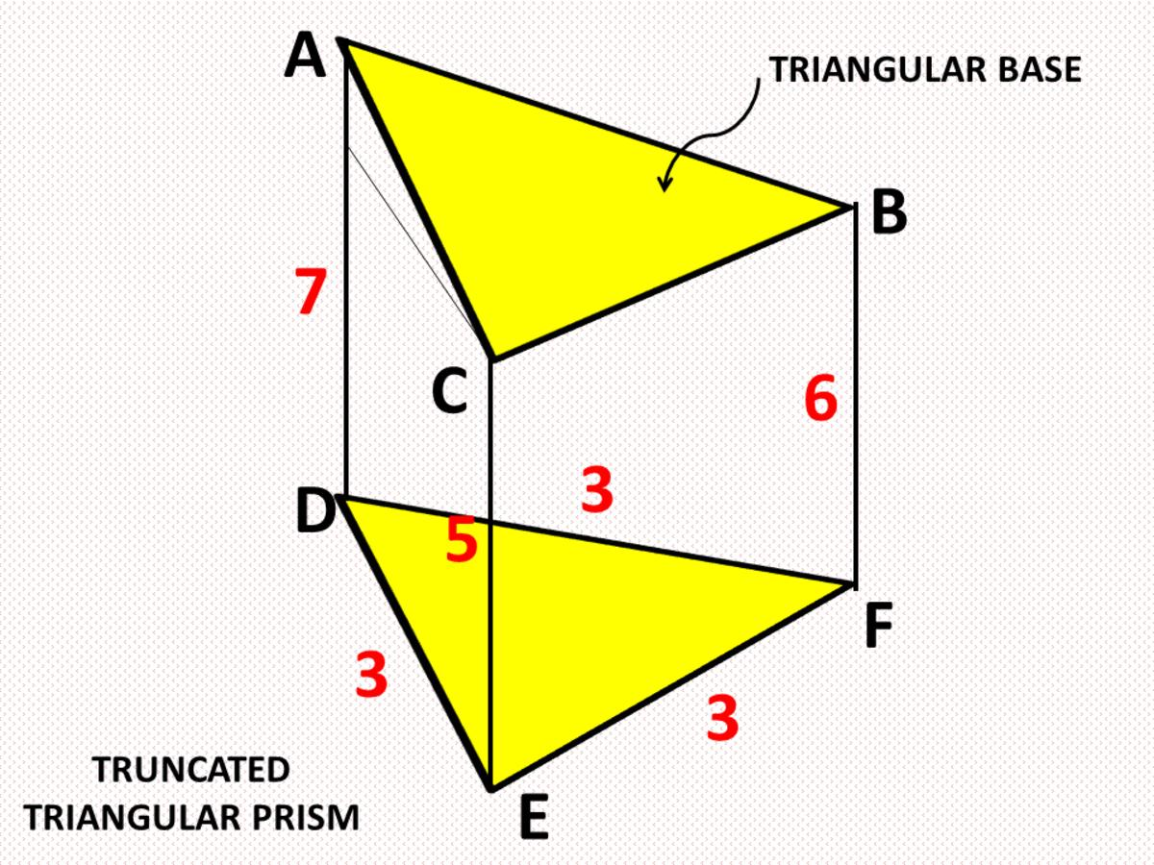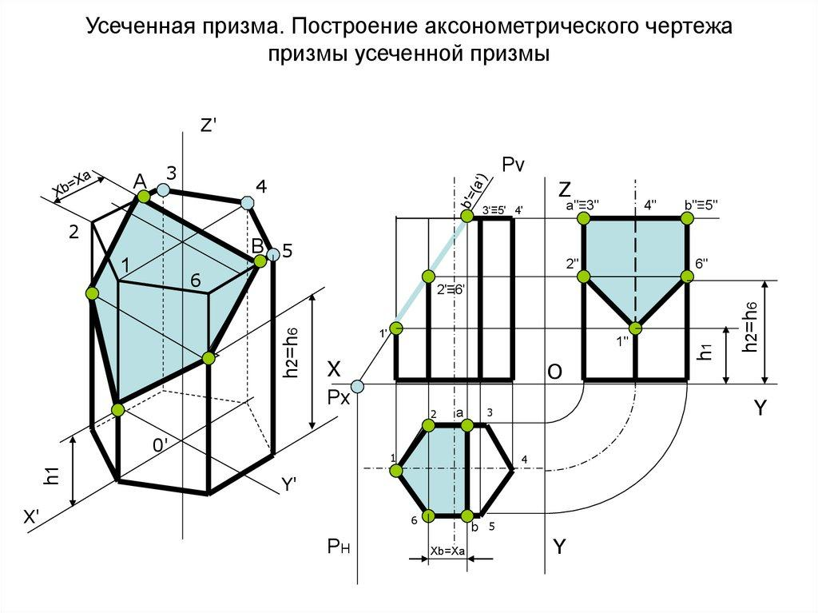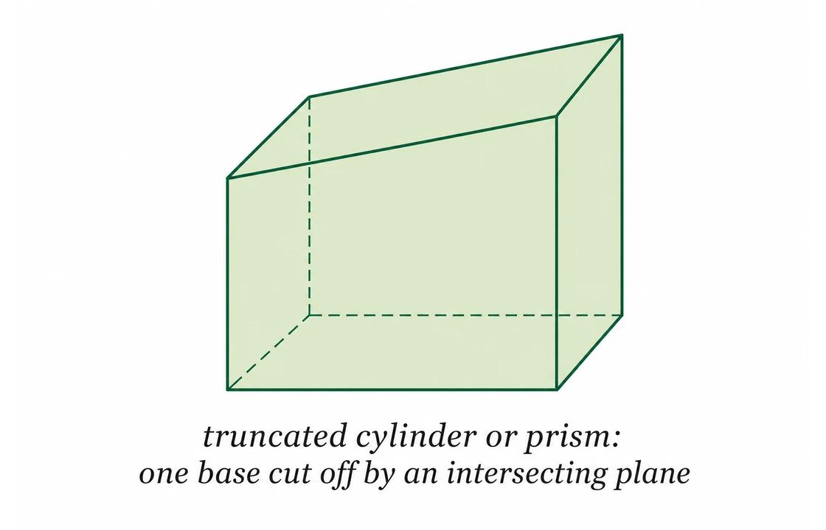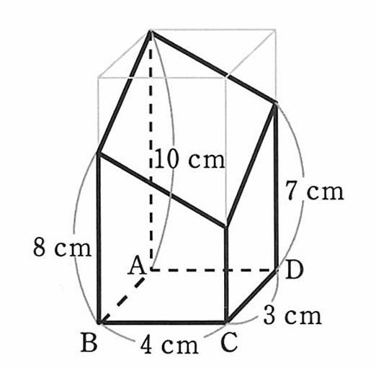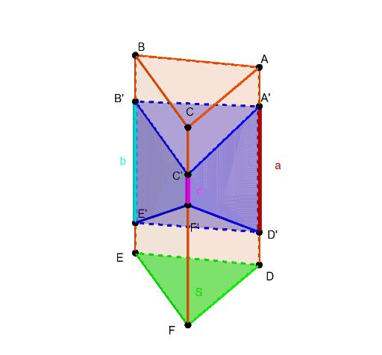
These are formed by cutting a prism with one or more planes.
Examples:
- Truncated Triangular Prism
- Truncated Rectangular Prism
- Truncated Hexagonal Prism
- Obliquely Truncated Prism

Truncated Pyramids
# Source: AI Source: Provided by: [Data Path: Persons Table -> ID Column: 1, Name_En Column: Motasem Essam] -> From: [ChatGPT] on [7/25/2026]
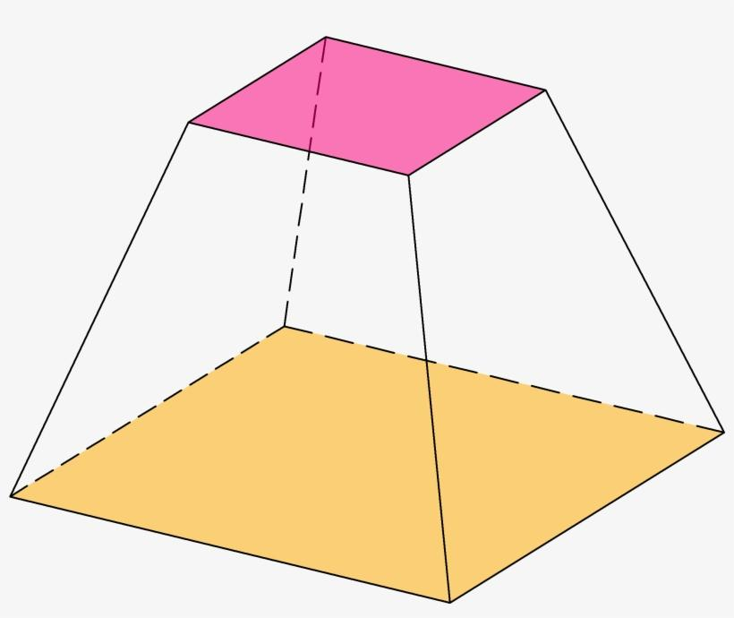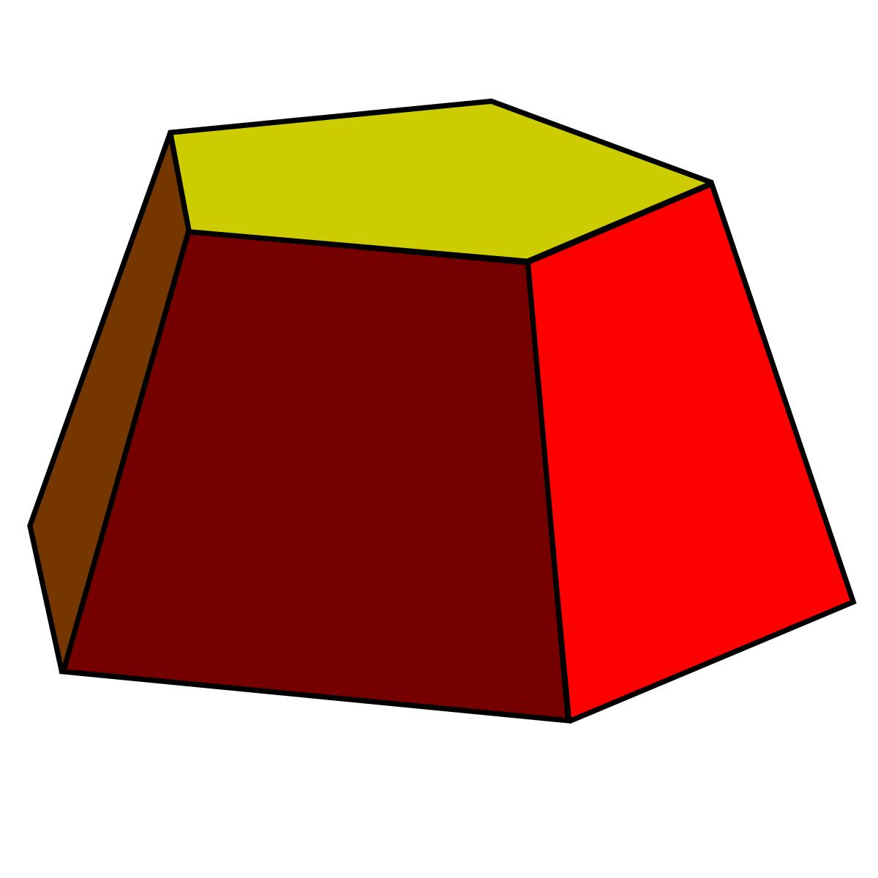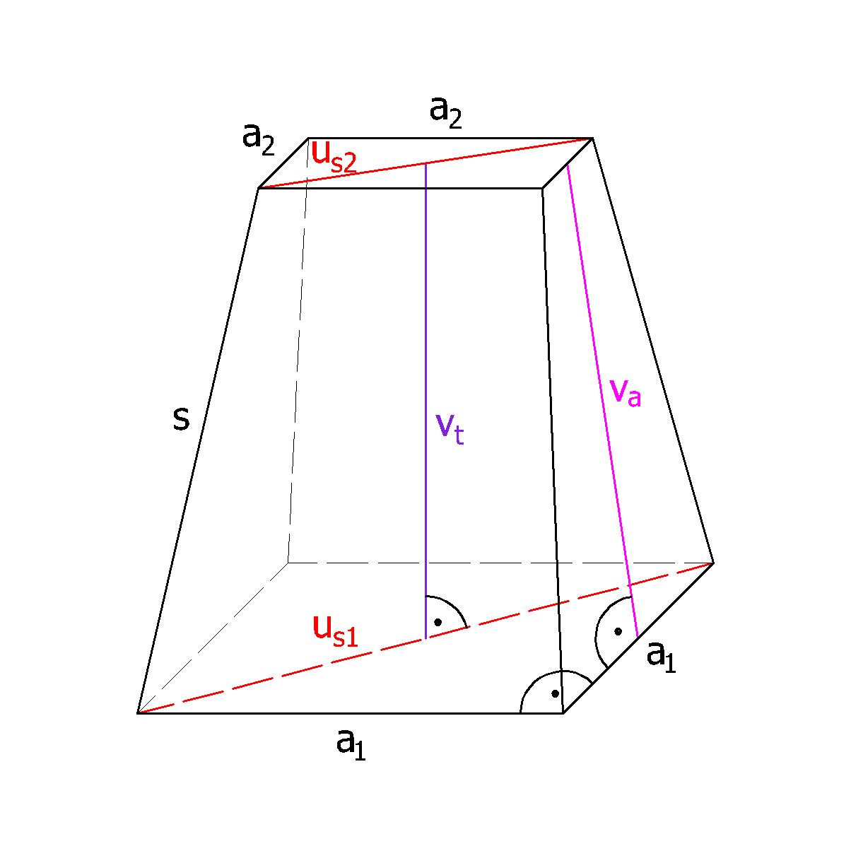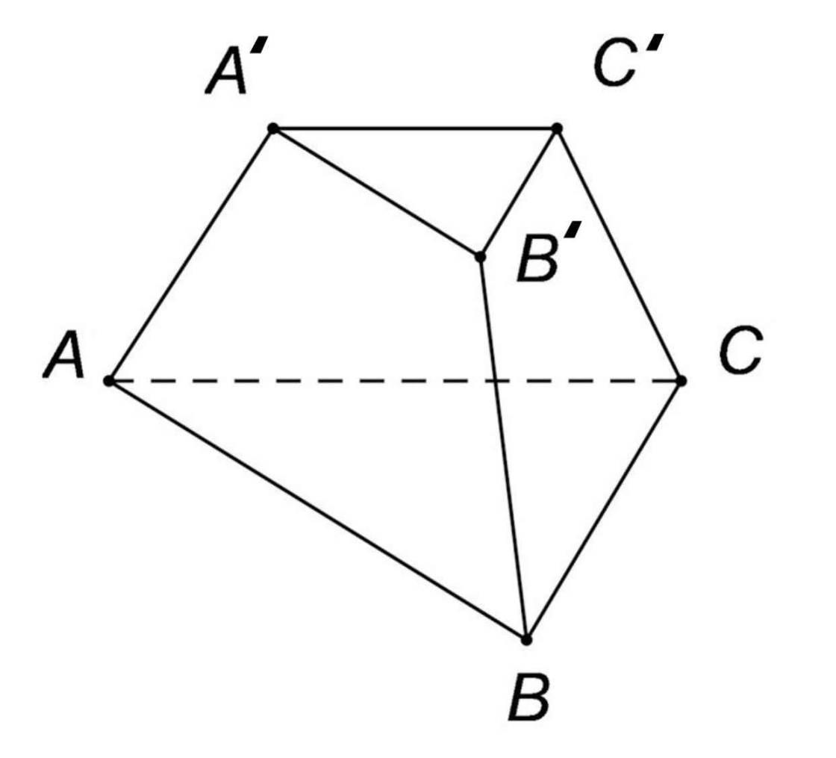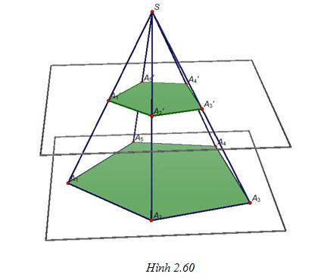
These are formed by removing the apex or an upper portion of a pyramid using a cutting plane.
Examples:
- Triangular Truncated Pyramid
- Square Truncated Pyramid
- Pentagonal Truncated Pyramid
- Hexagonal Truncated Pyramid
Special case: A truncated pyramid produced by a plane parallel to its base is called a Pyramidal Frustum.

Truncated Cones
# Source: AI Source: Provided by: [Data Path: Persons Table -> ID Column: 1, Name_En Column: Motasem Essam] -> From: [ChatGPT] on [7/25/2026]
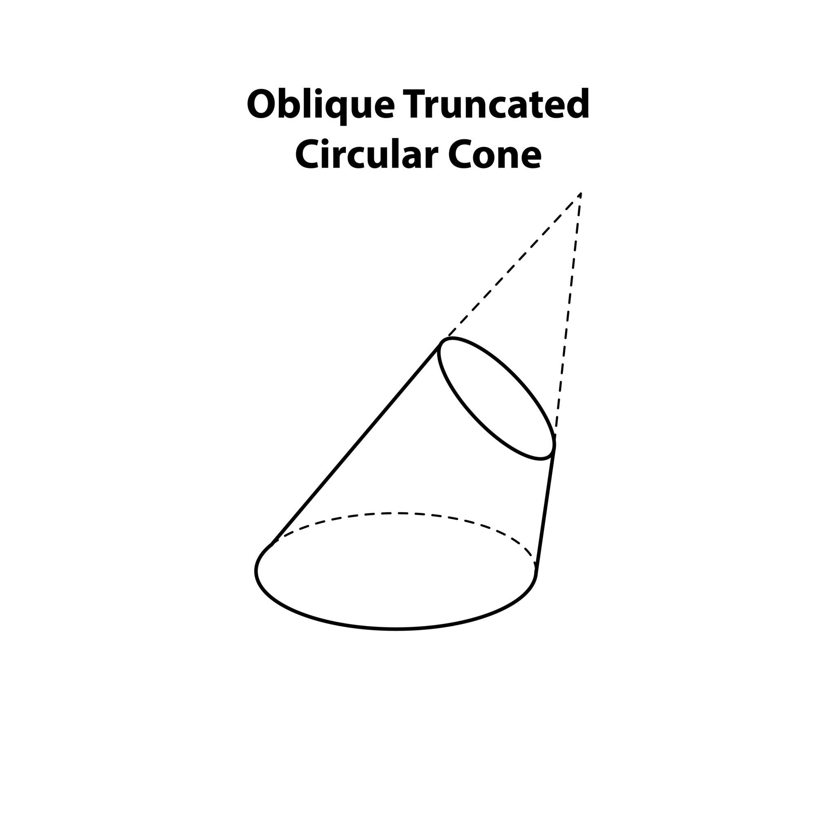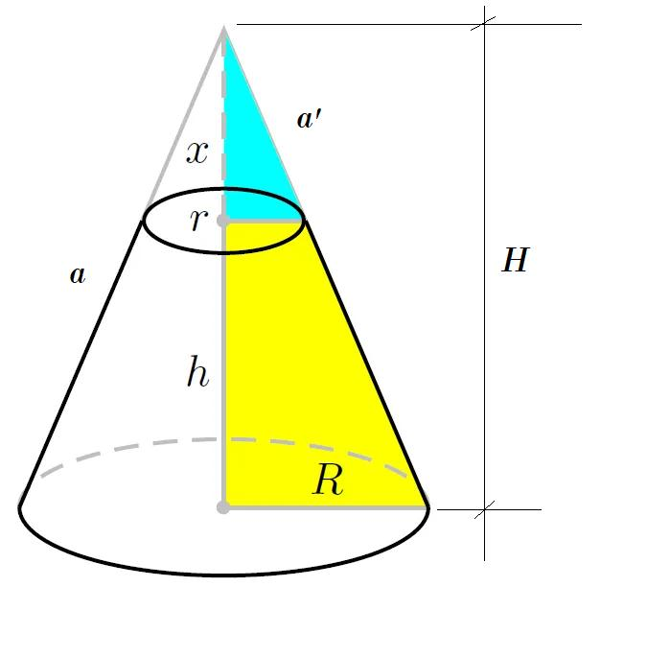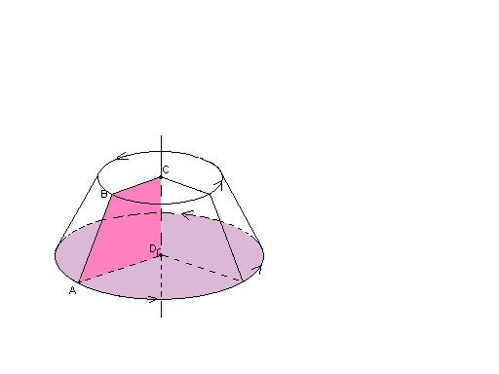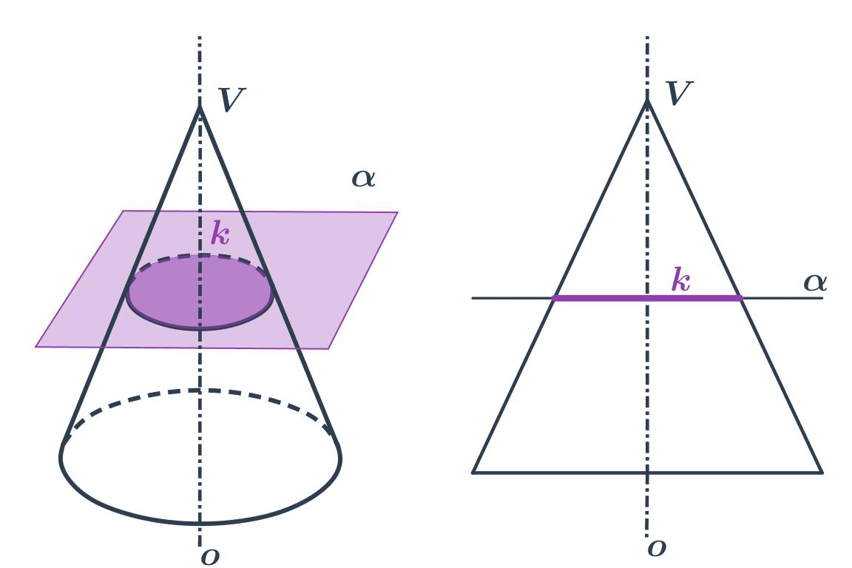
These are formed by cutting a cone with a plane.
Examples:
- Right Circular Conical Frustum
- Oblique Conical Frustum
- Inclined-Cut Cone
- Eccentrically Truncated Cone
Special case: A cone cut by a plane parallel to its circular base produces a Conical Frustum.

Truncated Cylinders
# Source: AI Source: Provided by: [Data Path: Persons Table -> ID Column: 1, Name_En Column: Motasem Essam] -> From: [ChatGPT] on [7/25/2026]
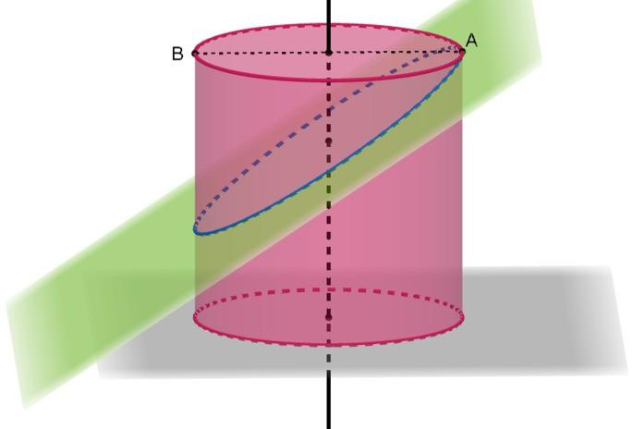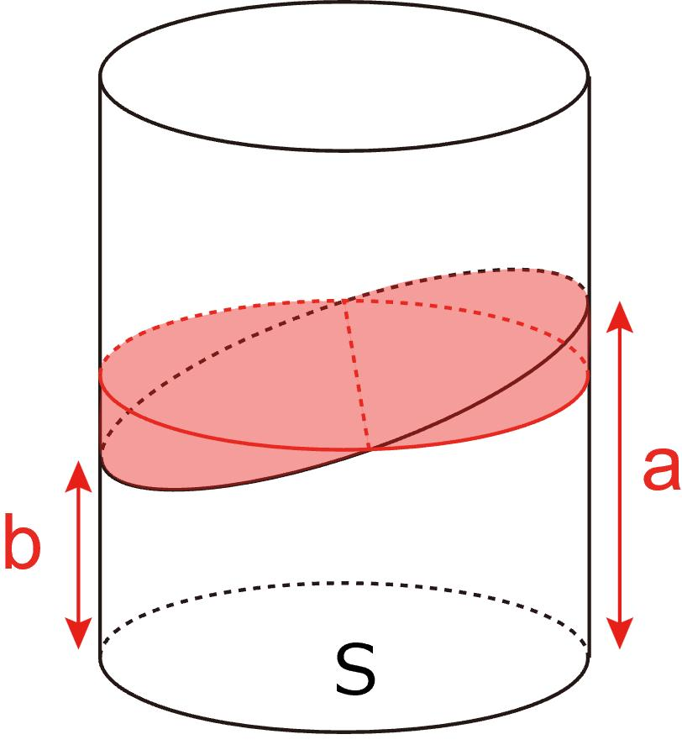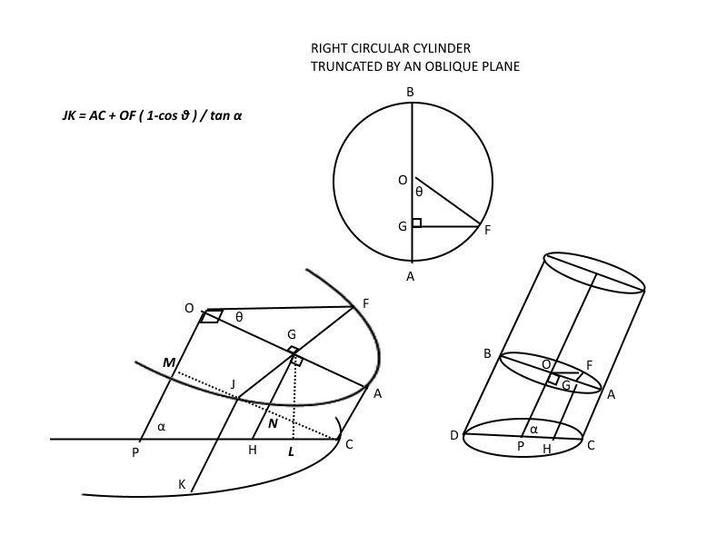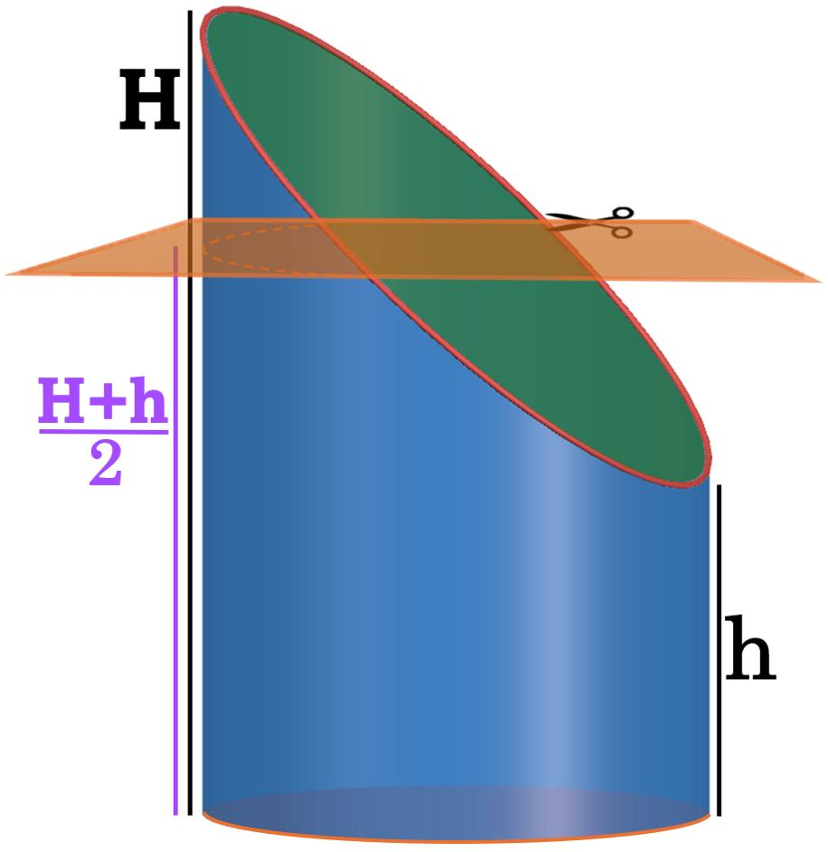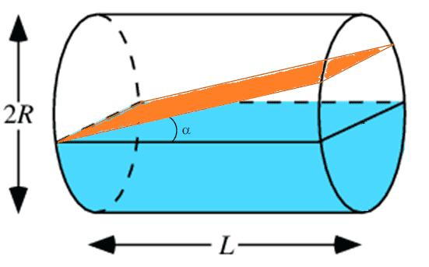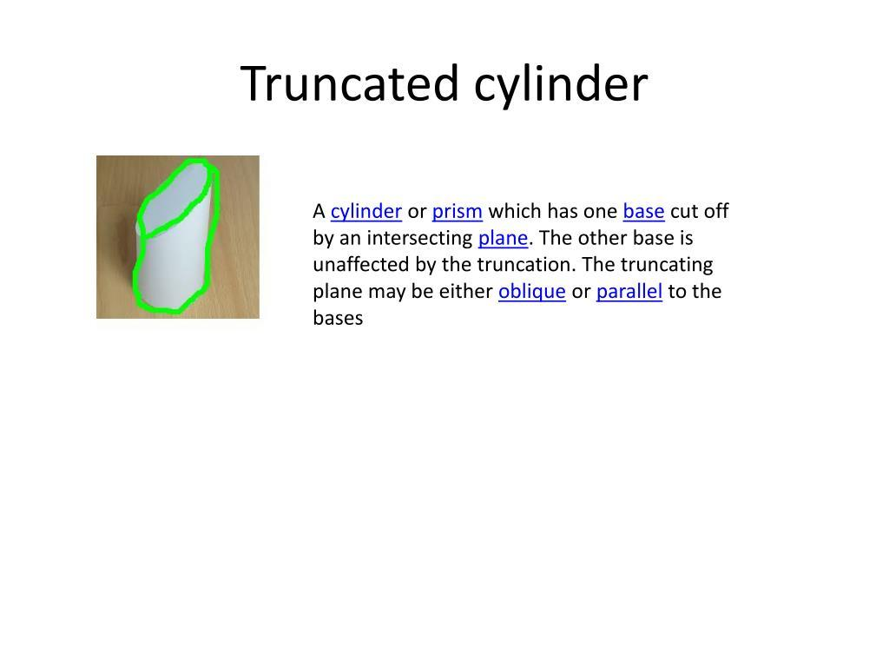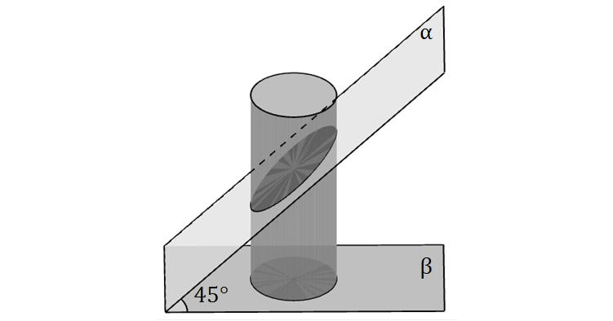
These are formed by cutting a cylinder with one or more planes.
Examples:
- Horizontally Truncated Cylinder
- Obliquely Truncated Cylinder
- Inclined-Cut Circular Cylinder
- Partially Truncated Cylinder

Truncated Spheres
# Source: AI Source: Provided by: [Data Path: Persons Table -> ID Column: 1, Name_En Column: Motasem Essam] -> From: [ChatGPT] on [7/25/2026]
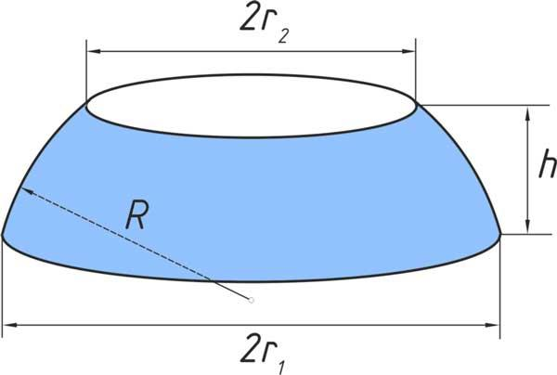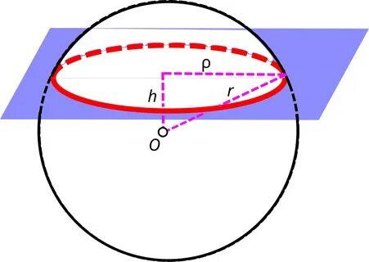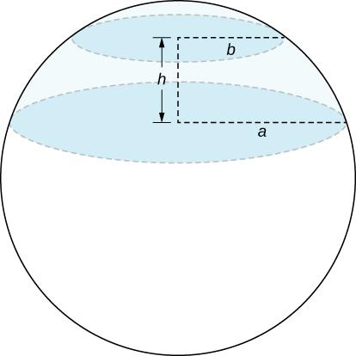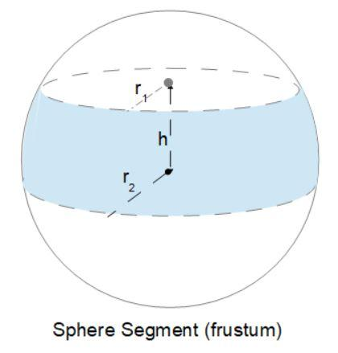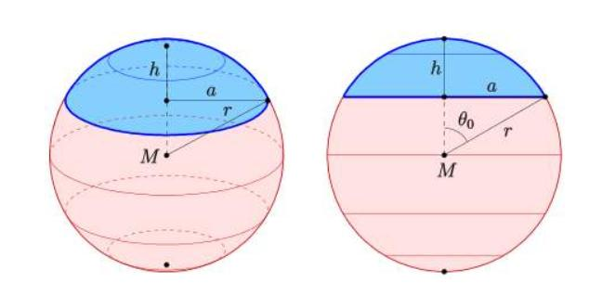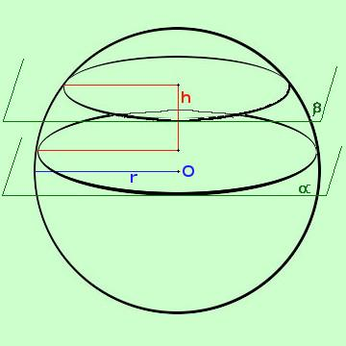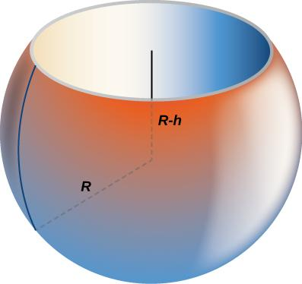
These are formed by cutting a sphere with one or more planes.
Examples:
- Spherical Cap
- Spherical Segment
- Spherical Zone
- Partially Truncated Sphere

Types Based on Cutting Plane Orientation
# Source: AI Source: Provided by: [Data Path: Persons Table -> ID Column: 1, Name_En Column: Motasem Essam] -> From: [ChatGPT] on [7/25/2026]
The orientation of the cutting plane determines the shape of the newly created face.
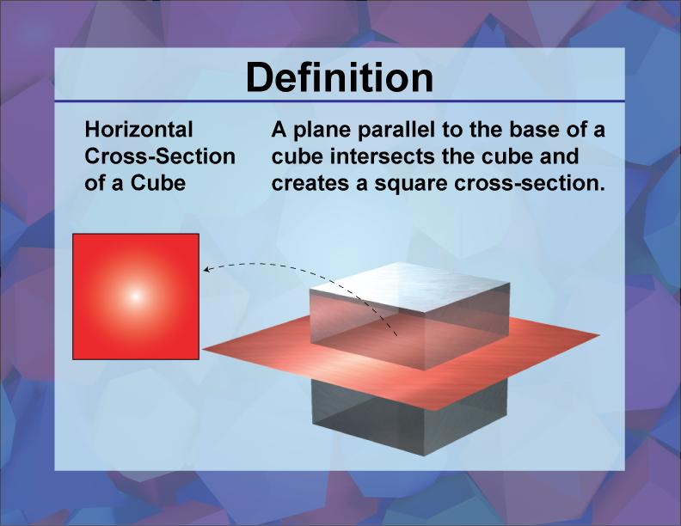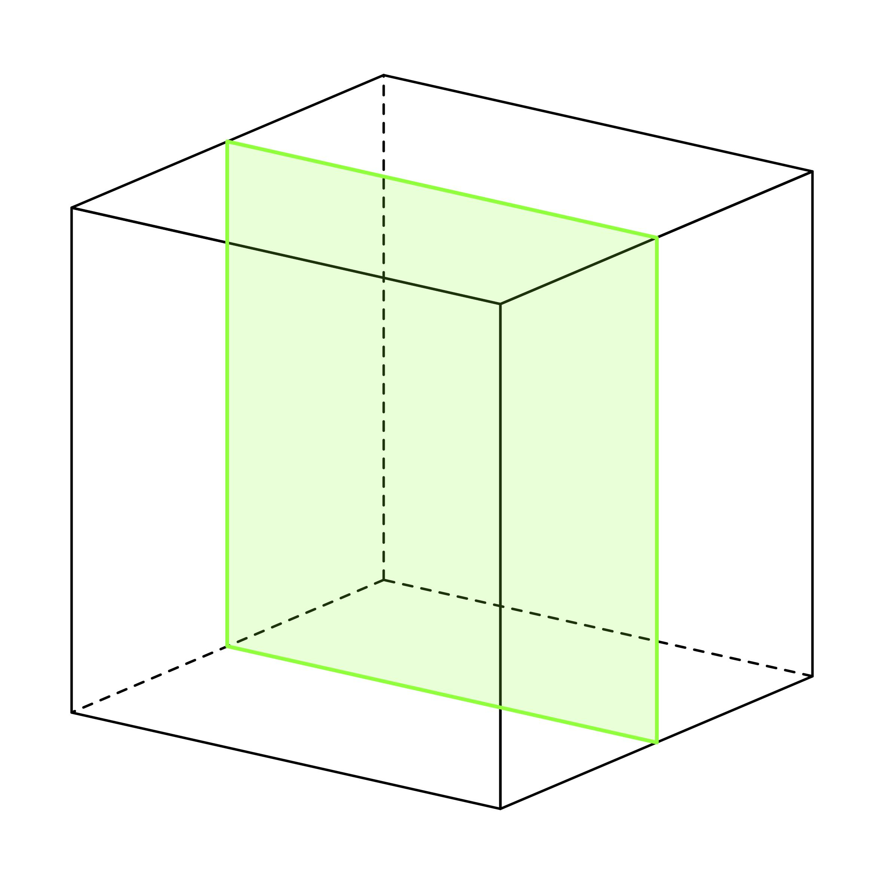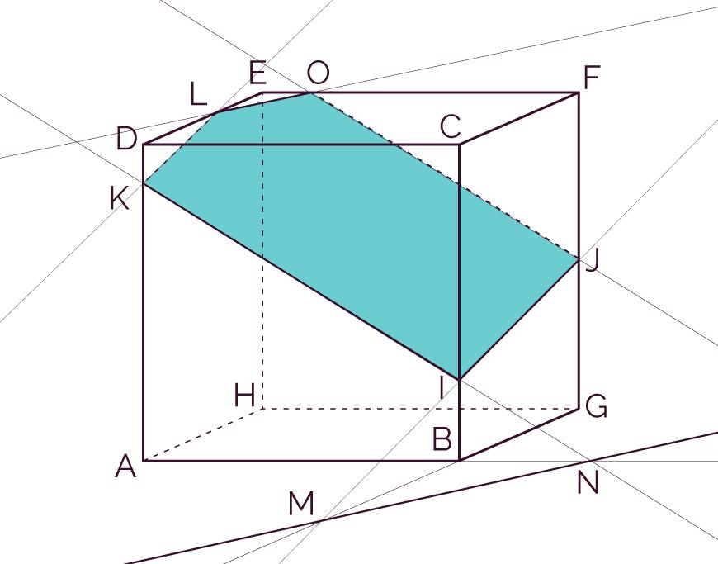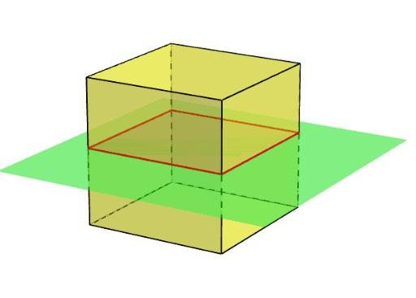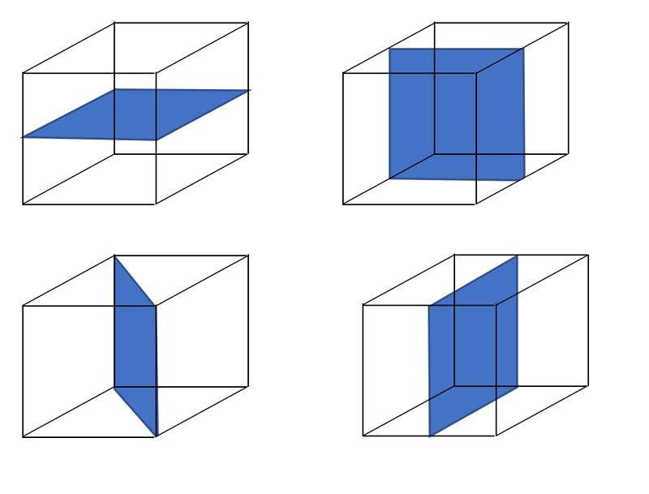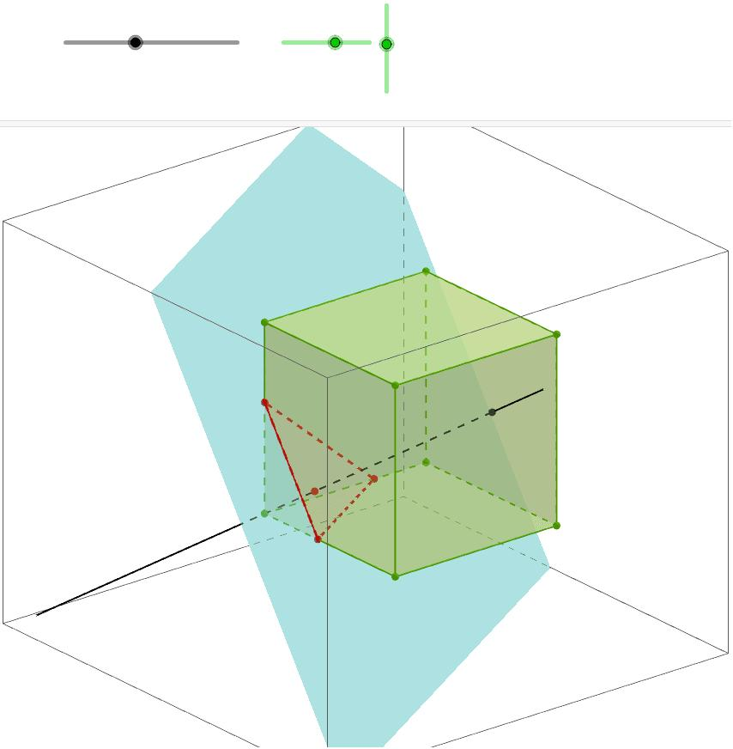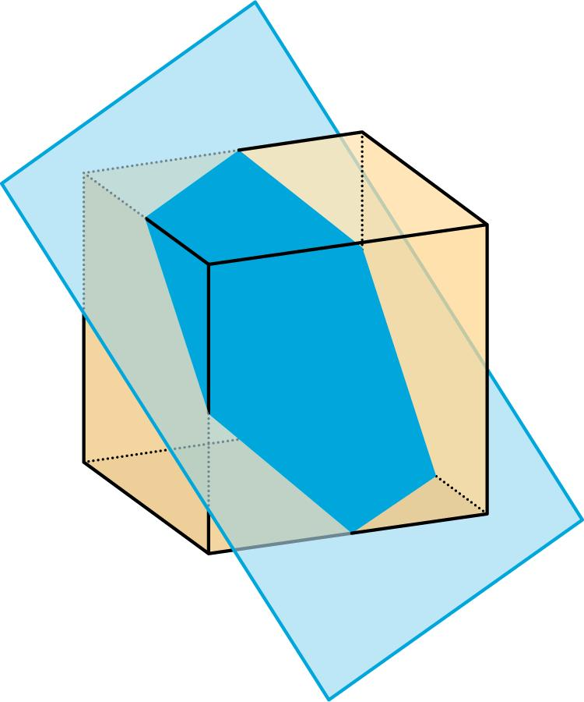
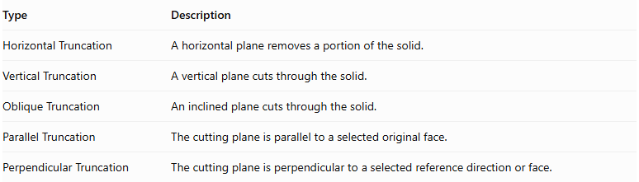
Type | Description
Horizontal Truncation | A horizontal plane removes a portion of the solid.
Vertical Truncation | A vertical plane cuts through the solid.
Oblique Truncation | An inclined plane cuts through the solid.
Parallel Truncation | The cutting plane is parallel to a selected original face.
Perpendicular Truncation | The cutting plane is perpendicular to a selected reference direction or face.

Truncation Face
# Source: AI Source: Provided by: [Data Path: Persons Table -> ID Column: 1, Name_En Column: Motasem Essam] -> From: [ChatGPT] on [7/25/2026]
The Truncation Face is the new face created when a solid is cut by a plane.
Its shape depends on the intersection between the cutting plane and the original solid.
Possible truncation-face shapes include:
- Triangle
- Quadrilateral
- Pentagon
- Hexagon
- Other polygons
- Circle
- Ellipse
For example:
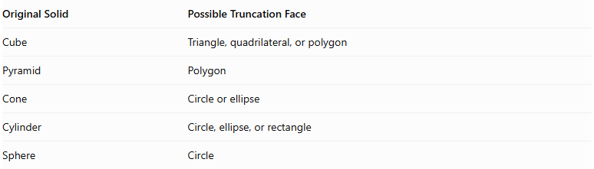
Original Solid | Possible Truncation Face
Cube | Triangle, quadrilateral, or polygon
Pyramid | Polygon
Cone | Circle or ellipse
Cylinder | Circle, ellipse, or rectangle
Sphere | Circle

Mathematical Properties
# Source: AI Source: Provided by: [Data Path: Persons Table -> ID Column: 1, Name_En Column: Motasem Essam] -> From: [ChatGPT] on [7/25/2026]
The mathematical properties of a truncated solid depend on:
- The original solid.
- The number of cutting planes.
- The orientation of each cutting plane.
- The dimensions of the removed portion.
- The shape of the resulting truncation face.
For a convex polyhedron truncated by a plane that intersects its boundary without passing through existing vertices or edges, the new face is a polygon.
For a convex polyhedron, Euler's formula remains valid:
$$V-E+F=2$$
where:
- $V$ = number of vertices.
- $E$ = number of edges.
- $F$ = number of faces.

Surface Area and Volume
# Source: AI Source: Provided by: [Data Path: Persons Table -> ID Column: 1, Name_En Column: Motasem Essam] -> From: [ChatGPT] on [7/25/2026]
There is no single surface-area or volume formula for all truncated solids.
Volume
The remaining volume is:
$$V_{remaining}=V_{original}-V_{removed}$$
Surface Area
The resulting surface area is calculated by adding the areas of all remaining external surfaces, including the newly created truncation face.
$${SA}_{truncated}={SA}_{remaining original surfaces}+{SA}_{truncation faces}$$
The areas of removed surfaces must not be included.

Relationship to Other Solids
# Source: AI Source: Provided by: [Data Path: Persons Table -> ID Column: 1, Name_En Column: Motasem Essam] -> From: [ChatGPT] on [7/25/2026]
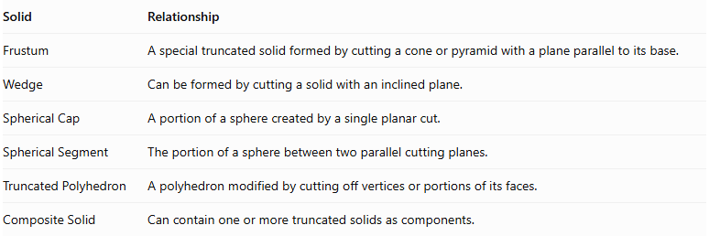
Solid | Relationship
Frustum | A special truncated solid formed by cutting a cone or pyramid with a plane parallel to its base.
Wedge | Can be formed by cutting a solid with an inclined plane.
Spherical Cap | A portion of a sphere created by a single planar cut.
Spherical Segment | The portion of a sphere between two parallel cutting planes.
Truncated Polyhedron | A polyhedron modified by cutting off vertices or portions of its faces.
Composite Solid | Can contain one or more truncated solids as components.

Key Points
# Source: AI Source: Provided by: [Data Path: Persons Table -> ID Column: 1, Name_En Column: Motasem Essam] -> From: [ChatGPT] on [7/25/2026]
- A truncated solid is created by removing a portion of an original solid.
- Truncation can be performed on polyhedra and curved solids.
- A cutting plane creates a new truncation face.
- The truncation face can be polygonal or curved.
- Cutting-plane orientation affects the resulting geometry.
- A frustum is a special type of truncated solid.
- Volume is calculated by subtracting the removed portion.
- Surface area includes the newly exposed truncation surface.

Conclusion
# Source: AI Source: Provided by: [Data Path: Persons Table -> ID Column: 1, Name_En Column: Motasem Essam] -> From: [ChatGPT] on [7/25/2026]
A Truncated Solid is a broad category of three-dimensional solids produced by cutting away one or more portions of an original solid. It includes truncated polyhedra, prisms, pyramids, cones, cylinders, and spheres.
Classification note: For your Solid Geometry taxonomy, use Truncated Solids as a parent category, then classify its children according to the original solid:
- Truncated Polyhedra
- Truncated Prisms
- Truncated Pyramids
- Truncated Cones
- Truncated Cylinders
- Truncated Spheres
Keep Frustums as a specialized category under truncated solids, since they are formed by cuts parallel to the original base.

